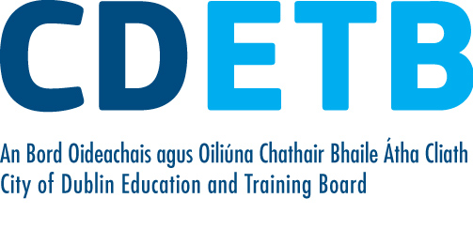
Application for Transfer within
City of Dublin Education and Training Board
CLOSING DATE IS MONDAY, 1st MARCH 2021

Personal details
Full name
Postal address
Email address |  | Contact number

Current position
Post title
College/Centre
Post of responsibility (if applicable)
Date of commencement (wholetime) with CDETB

Preferred location
List of Schools/Centres within CDETB to which you are seeking transfer (in order of preference):
1.
2.
3.
4.

Qualifications
University and year of award | First year  subjects | Second year subjects | Third year subjects | Fourth year subjects
Other

Wholetime Teaching Experiences
Please state dates and subjects taught
With CDETB | From – To | Subjects taught
Other | From – To | Subjects taught

Other information you wish to give

Is your Principal aware that you are seeking a transfer? | Yes | ❒ | No | ❒

Signed: _____________________________ Date: _______________________

