Single Public Service Pension Scheme
Application for a Refund of Member Pension Contributions
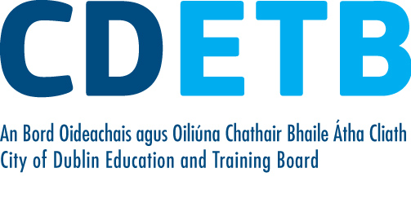
About this Form:
This form can be used by a former member of the Single Public Service Pension Scheme to claim a refund of their pension contribution on cessation of their employment with City of Dublin ETB; if:
1. It has been confirmed that the member has no entitlement to a long-term retirement benefit because they have paid contributions for less than 2 years as a member of the Scheme; and
2. The member is not taking up pensionable employment in another Public Service Body to which the terms of the Single Public Service Pension Scheme apply.
If you do not meet the above criteria, or if you are unsure as to whether or not you should complete this Form, you should contact the Pensions Officer in the City of Dublin ETB.
I wish to apply for a refund of the member pension contributions paid by me via the payroll of City of Dublin ETB during the period to .

Name: .
PPSN: __________________________________________
Home Address: __________________________________________
__________________________________________
__________________________________________
__________________________________________
Mobile number: __________________________________________
E-mail: __________________________________________

I declare:
- I have been a member of the Single Public Service Pension Scheme under all employments, for which contributions were not previously repaid, for less than 24 months in total.

- I am not presently employed in a pensionable position with another Public Service Body to which the terms of the Single Public Service Pension Scheme may apply.

In making this application, I note:
- That payment will be made by cheque from City of Dublin ETB to my address noted above.

- In the event that I am subsequently re-employed in a pensionable capacity in the Irish Public Service within 24 months of my ceasing employment with City of Dublin ETB, I may in the future reinstate the benefit amounts related to the refund received by repaying the contributions together with compound interest at rates determined by the Minister for Public Expenditure & Reform. If you take up employment in the public sector after cessation from CDETB you should contact the pension section if you wish to repay the refund within 24 months of ceasing with CDETB.

- City of Dublin ETB may undertake validation checks centrally with the Department of Public Expenditure & Reform.

Signature: _________________________________ Date: ____/____/____

Please return your fully completed Application Form to:
City of Dublin ETB, Pension Section, Town Hall, Merrion Road, Ballsbridge, Dublin 4.

