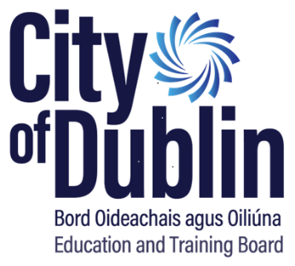

# City of Dublin ETB Taxsaver Terms & Conditions

Taxsaver Commuter Tickets/Credits are annual travel tickets/credits issued by Dublin Bus, Bus Eireann, Irish Rail, LUAS and Certain Private Bus Operators through employers. The employer orders the Ticket, pays the full cost in advance and issues the ticket to the Employee. The cost will then be deducted from the employee salary **January 2025 to October 2025 (10 months).**

The employee will not be liable for tax, PRSI or applicable levies on the salary foregone. If the employee is pensionable the reduction in gross pay will be made *after* the superannuation contribution is calculated, i.e. pensions will not be affected.

Full details of the scheme are available on **www.taxsaver.ie**

***The procedure is as follows:***

* Applicants should complete the Pay Mandate & Application Form (Appendix I) and return to City of Dublin ETB, Head Office by **11th December 2025 *Late applications will not be accepted.***
* The City of Dublin ETB will purchase the 2024 Annual Ticket/Credit and return the ticket to the employee by courier to the college/centre in time for use from 1st January 2025.
* The deductions from pay commence with the first payment of January 2025 to the employee. Employees who leave City of Dublin ETB's employment before 31st October 2025 will have the full balance owed to the City of Dublin ETB deducted from their final payment.
* Tax & levy relief will be automatic and it is not necessary for an employee to claim for it. However, the application form incorporates a signed mandate altering the employee’s conditions of service by reducing Gross Pay by the cost of the annual commuter ticket.
* The scheme is being operated by the City of Dublin ETB for its employees only. It is not possible for a City of Dublin ETB employee to purchase a ticket/credit on behalf of someone else.
* A separate application form is required for each year.
* The City of Dublin ETB’s involvement extends only to purchasing the ticket/credits and facilitating the deductions. The City of Dublin ETB will not become involved in any way in disputes or problems between employees and the ticket providers.
* **Lost tickets are replaced at a cost. Their replacement is a matter between the employee and the ticket provider. We recommend you register your Leapcard on www.leapcard.ie when received.**
* The scheme applies only to **Annual** tickets, from 1st January 2025 – 31st December 2025. City of Dublin ETB does not facilitate monthly ticket orders due to limited resources available to administer the scheme.
* As per the Department circular the choice exercised must be irrevocable for the relevant year and cannot be made more frequently than once a year. Therefore staff are advised to choose their annual ticket/credit carefully and contact the relevant provider with any specific queries before submitting the application form to Head Office. **Once purchased, there will not be a facility to change ticket/credit types etc throughout the year. Please note that ticket cancellations will not be processed except in exceptional cases such as maternity or long-term sick leave which will be considered on a case-by-case basis.**
* Please note that all tickets purchased from Irish Rail, Dublin Bus, Bus Eireann & LUAS, are treated by the provider as 10 month tickets, with the last two free. **Please note that a refund from the transport provider is not always possible. In such cases the employee is liable for the full costs of the ticket and the City of Dublin ETB shall recover any balances owed by the employee.**
* Blank application forms are available from the City of Dublin ETB staff intranet, Sharepoint or emailing by taxsaver@cdetb.ie
* Please address any queries regarding eligibility for the scheme to **taxsaver@cdetb.ie**

**Reminder: Closing date – Friday 11th December 2024**

* + - ***Late applications will not be accepted.***

Signed: City of Dublin ETB Taxsaver Dept.

Date: 19.11.2024